Dear Friend,

Thank you so much for considering going on a mission trip with Bonsack Baptist Church. Your desire to serve Christ is of paramount importance to us and we desire to do all that we can to help you fulfill your calling to that service.

The following forms are intended to help us ensure that we are providing as safe and secure an environment as we possibly can for the individuals with whom we are providing volunteer services. There is no intent that this process, in any way, becomes an affront to your character or value to Virginia Baptists.

➢Consent to Obtain Background Check
o This form will give BBC the authorization to obtain consumer reports relating to you. These reports will be held in the strictest of confidence. If an individual has any criminal history this may prevent him/her from serving as on the mission trip.

➢Volunteer Information Form

➢Volunteer Expectations
o This form simply acknowledges your understanding of the behavior we expect of our volunteers.

We trust that you approve of the high standard that we are choosing to set for our volunteers as well as our participants. If you have any questions or concerns about these forms or our process please do not hesitate to contact us.
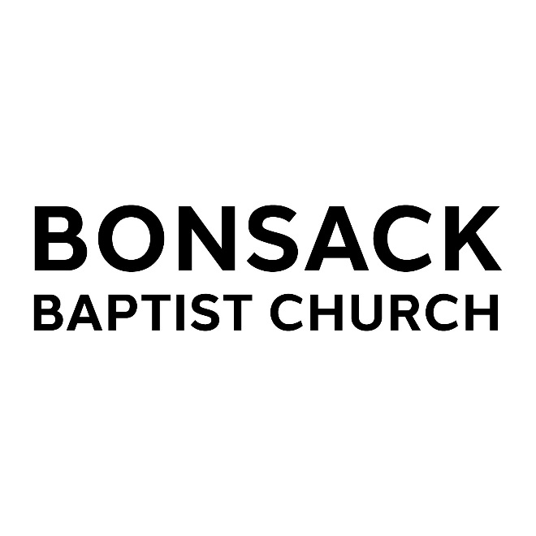
CONSENT TO OBTAIN BACKGROUND CHECK VOLUNTEER

I hereby give my permission for Bonsack Baptist Church to obtain a detailed background report from background checking agencies in connection with my application for a mission trip. I understand thatthe reports that Bonsack Baptist Church obtains may include information about my driving/DMV record and/or my criminal conviction background consistent with state and federal law.

I understand that before an adverse decision is taken based, in whole or in part, on information contained in the report, I will be provided a copy of the reportand a description in writing of my rights under the Fair Credit Reporting Act.

By signing below, I hereby authorize Bonsack Baptist Church to procure background reports as stated above and affirm that all the information provided in this form is true and accurate.

Print Full Legal Name ______________________________________________________________

Home/Mobile/Work Phone Numbers__________________________________________________

Applicant’s Signature _________________________________________Date__________________

When completed, please return to: Bonsack Baptist Church
4845 Cloverdale Rd
Roanoke, VA 24019

MISSION TRIP PARTICIPANT INFORMATION FORM

Full Given Name _______________________________________________________________________ First Middle Maiden Last

Current Address (not P.O. Box)______________________________________________________ Number Street Apt. #

________________________________________________________________________________ City County State Zip Code

How long have you been at this address? _______________________________________________

If less than one year, please give previous address ________________________________________ Number Street Apt.#
________________________________________________________________________________ City County State Zip Code

Church Name and Address___________________________________________________________

Gender: (please indicate) Male ______ Female ______

Date of Birth: __ __ Month
/ __ __ / __ __ __ __ Day Year

Social Security Number ________ - _______ - __________
(MANDATORY – this is necessary to correctly identify volunteer applicants. If you are uncomfortable sending this information in with this application then please call and give it to us over the phone)

Driver’s License # ____________________________ Issuing State _________

Have you ever been convicted of a crime? _____yes _____no Criminal convictions will not necessarily bar volunteer service.

Are there any criminal charges pending against you? _____yes _____no Opportunity to volunteer may be delayed until resolution of charges.

If yes to either of the above, please explain: ______________________________________________________

_________________________________________________________________________________________

The signature represents my current legal name and any previously used names are listed below:

Additional names: _________________________

_________________________________________ Signature of Applicant
_________________________

________________ Date

BONSACK BAPTIST CHURCH MISSION TRIP EXPECTATIONS

While serving as part of a Bonsack Baptist Church Mission Trip the following rules shall apply:

1) Using, possessing, or being under the influence of tobacco products, alcohol, illegal, or illicit drugs will not be tolerated.
2) Volunteers serving with minors or the intellectually or physically disabled shall not abuse said individuals, including:
Any direct observations or evidence of sexual activity in the presence of or in association with individuals;
Any display or demonstration of sexual activity, abuse, insinuation of abuse, or evidence of abusive conduct towards an individual;
Sexual advances or sexual activity of any kind;
Infliction of physically abusive behavior or bodily injury to an individual;
Physical neglect of an individual, including failure to provide adequate supervision in relation to the activities of Virginia Baptist Mission Board.
Actions causing mental or emotional injury to an individual;
The presence or possession of obscene or pornographic materials at any function of Virginia Baptist Mission Board.
The presence, possession, or being under the influence of any illegal, illicit drugs;
The consumption of or being under the influence of alcohol while leading or participating in a function for individuals of Virginia Baptist Mission Board.
3) Volunteers must treat all people with respect and consideration.
4) Volunteers shall not use or tolerate the use of profanity in the presence of individuals.
5) Volunteers must be free of physical and psychological conditions that might adversely affect any individual’s health, including, but not limited to, contagious disease.
6) Volunteers will portray a positive role model for individuals by maintaining an attitude of respect, loyalty, patience, courtesy, and maturity.
7) Volunteers will be expected to act and react with Christian love and understanding in all situations.
8) Volunteers will do everything in their power to avoid being put in a situation where they are alone with a minor or the intellectually or physically disabled other than one in their own custodial responsibility.
9) I understand that any violation of this code may result in my removal as a volunteer with the VBMB. 10) I understand that I am a volunteer at will, meaning that either I or the VBMB may end the volunteer
relationship at any time and for any reason.

